Contents

[Quick Tutorials 2](#_Toc474190567)

[**Perceptron** 2](#_Toc474190568)

[**Weights** 3](#_Toc474190569)

[**Summing the Input Data** 3](#_Toc474190570)

[**Calculating the Output with an Activation Function** 4](#_Toc474190571)

[**AND Perceptron Quiz** 5](#_Toc474190572)

[**What are the weights and bias for the AND perceptron?** 5](#_Toc474190573)

[XOR Perceptron 6](#_Toc474190574)

[Quiz 7](#_Toc474190575)

[**QUIZ QUESTION** 7](#_Toc474190576)

[The simplest neural network 9](#_Toc474190577)

[Simple network exercise 10](#_Toc474190578)

[Learning weights 11](#_Toc474190579)

[Enter Gradient Descent 11](#_Toc474190580)

[Math time 12](#_Toc474190581)

[Caveats 15](#_Toc474190582)

[Gradient descent exercise 16](#_Toc474190583)

[Implementing gradient descent 18](#_Toc474190584)

[Data cleanup 18](#_Toc474190585)

[Implementing with Numpy 20](#_Toc474190586)

[Efficiency tip! 20](#_Toc474190587)

[Programming exercise 20](#_Toc474190588)

[Multilayer perceptron: Implementing the hidden layer 21](#_Toc474190589)

[Making a column vector 23](#_Toc474190590)

[Programming quiz 24](#_Toc474190591)

[Backpropagation for multi layer perceptron’s 24](#_Toc474190592)

[Working through an example 25](#_Toc474190593)

[Implementing in Numpy 27](#_Toc474190594)

[Backpropagation exercise 27](#_Toc474190595)

[Further reading 28](#_Toc474190596)

# Quick Tutorials

<http://pandas.pydata.org/pandas-docs/stable/10min.html#min>

<http://scikit-learn.org/stable/tutorial/basic/tutorial.html>

<http://matplotlib.org/users/pyplot_tutorial.html>

<http://cs231n.github.io/python-numpy-tutorial/>

<https://docs.scipy.org/doc/numpy-dev/user/quickstart.html>

<https://jakevdp.github.io/blog/2016/08/25/conda-myths-and-misconceptions/>

<https://vimeo.com/170189199>

* From Andrej Karpathy: [**Yes, you should understand backprop**](https://medium.com/@karpathy/yes-you-should-understand-backprop-e2f06eab496b#.vt3ax2kg9)
* Also from Andrej Karpathy, [**a lecture from Stanford's CS231n course**](https://www.youtube.com/watch?v=59Hbtz7XgjM)

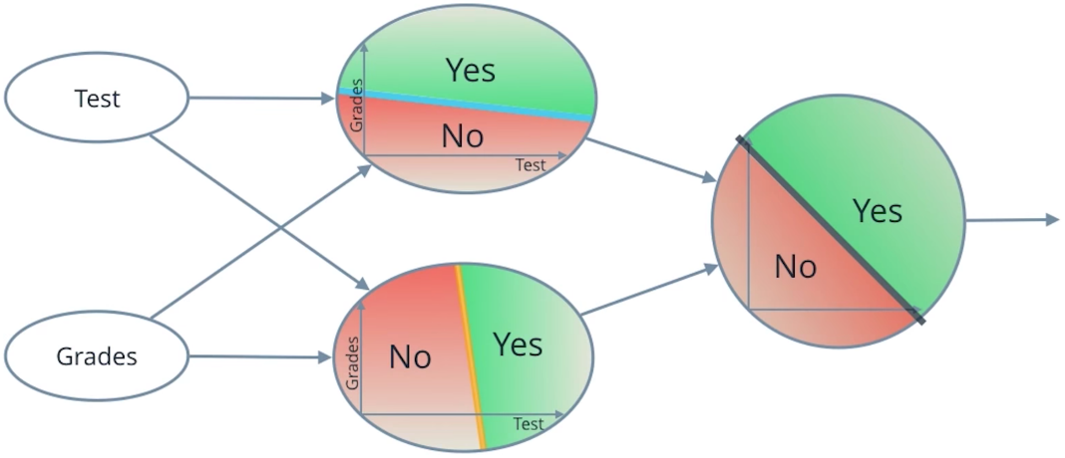

Neural Network

**Perceptron**

Now you've seen how a simple neural network makes decisions: by taking in input data, processing that information, and finally, producing an output in the form of a decision! Let's take a deeper dive into the university admission example and learn more about how this input data is processed.

Data, like test scores and grades, is fed into a network of interconnected nodes. These individual nodes are called **[perceptrons](https://en.wikipedia.org/wiki/Perceptron" \t "_blank)** or neurons, and they are the basic unit of a neural network. *Each one looks at input data and decides how to categorize that data.* In the example above, the input either passes a threshold for grades and test scores or doesn't, and so the two categories are: yes (passed the threshold) and no (didn't pass the threshold). These categories then combine to form a decision -- for example, if both nodes produce a "yes" output, then this student gains admission into the university.

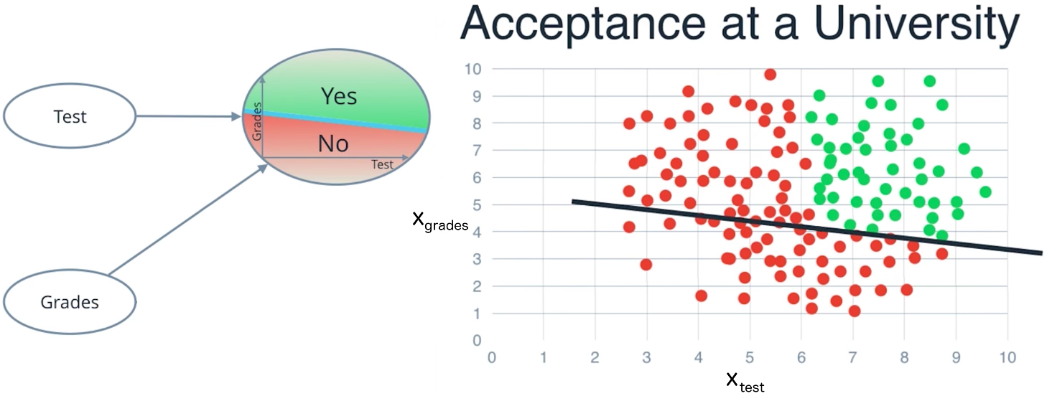

Let's zoom in even further and look at how a single perceptron processes input data.

The perceptron above is one of the two perceptrons from the video that help determine whether or not a student is accepted to a university. It decides whether a student's grades are high enough to be accepted to the university. You might be wondering: "How does it know whether grades or test scores are more important in making this acceptance decision?" Well, when we initialize a neural network, we don't know what information will be most important in making a decision. It's up to the neural network to *learn for itself* which data is most important and adjust how it considers that data.

It does this with something called **weights**.

**Weights**

When input data comes into a perceptron, it gets multiplied by a weight value that is assigned to this particular input. For example, the perceptron above have two inputs, tests for test scores and grades, so it has two associated weights that can be adjusted individually. These weights start out as random values, and as the neural network network learns more about what kind of input data leads to a student being accepted into a university, the network adjusts the weights based on any errors in categorization that the previous weights resulted in. This is called **training** the neural network.

A higher weight means the neural network considers that input more important than other inputs, and lower weight means that the data is considered less important. An extreme example would be if test scores had no affect at all on university acceptance; then the weight of the test score input data would be zero and it would have no affect on the output of the perceptron.

**Summing the Input Data**

So, each input to a perceptron has an associated weight that represents its importance and these weights are determined during the learning process of a neural network, called training. In the next step, the weighted input data is summed up to produce a single value, that will help determine the final output - whether a student is accepted to a university or not. Let's see a concrete example of this.

We'll use *w*​*grades*​​ for the weight of grades and *w*​*test*​​ for the weight of test. For the image above, let's say that the weights are: *w*​*grades*​​=−1,*w*​*test*​​ =−0.2. You don't have to be concerned with the actual values, but their relative values are important. *w*​*grades*​​ is 5 times larger than *w*​*test*​​, which means the neural network considers grades input 5 times more important than test in determining whether a student will be accepted into a university. After applying these weights to the input data, the perceptron then sums these numbers to get a value we'll call the **linear combination**, which is pictured below. In the equation, *x*​*grades*​​ represents grades and *x*​*test*​​ represents test scores.

The linear combination represents how much the perceptron believes a student will be accepted into a university.

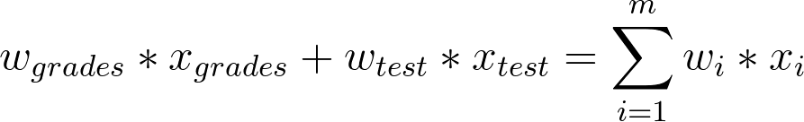

Linear Combination

**Calculating the Output with an Activation Function**

Finally, the result of the perceptron's summation is turned into an output signal! This is done by feeding the linear combination into an **activation function**.

One of the simplest activation functions is the **Heaviside step function**. This function returns a 0 if the linear combination it sees is negative or equal to zero, and 1 in any other case (when the linear combination is positive). The [**Heaviside step function**](https://en.wikipedia.org/wiki/Heaviside_step_function) is shown below, where h is the calculated linear combination:

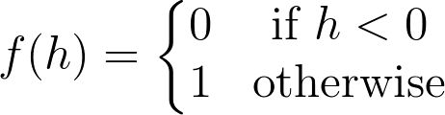

Heaviside Step Function

In the university acceptance example above, we used the weights *w*​*grades*​​=−1,*w*​*test*​​ =−0.2. Since *w*​*grades*​​and *w*​*test*​​ are negative values, the activation function will only return a 1 if grades and test are 0! This is because the range of values from the linear combination using these weights and inputs are (−∞,0].

We want more than one set of inputs to return a 1. We want a range of scores and grades that will be acceptable for the university. You can solve this problem by adding a single number to the linear combination called a **bias**, b. Just like the weights, the bias is also updated and changed by the neural network during training. Now with this value, we have a complete perceptron formula:

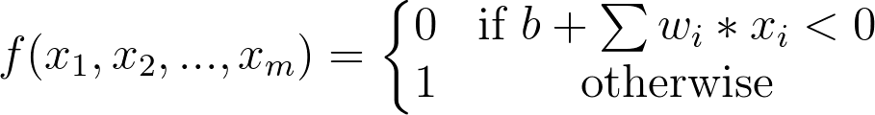

Perceptron Formula

This formula returns 1 if the input (*x*​1​​,*x*​2​​,...,*x*​*m*​​) belongs to the accepted-to-university category or returns 0if it doesn't. The input is made up of one or more [**real numbers**](https://en.wikipedia.org/wiki/Real_number), each one represented by *x*​*i*​​, where *m* is the number of inputs.

Then the neural network starts to learn! Initially, the weights ( *w*​*i*​​) and bias (*b*) are assigned a random value, and then they are updated using a learning algorithm like gradient descent. The weights and biases change so that the next training example is more accurately categorized, and patterns in data are "learned" by the neural network.

Now that you have a good understanding of perceptions, let's put that knowledge to use. In the next section, you'll create the AND perceptron from the *Neural Networks* video by setting the values for weights and bias.

**AND Perceptron Quiz**

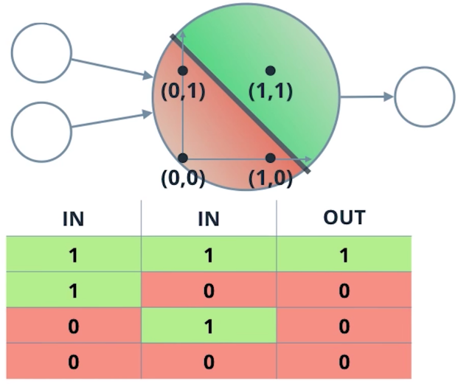

AND Perceptron

**What are the weights and bias for the AND perceptron?**

Set the weights (weight1, weight2) and bias bias to the correct values that calculate AND operation as shown above.

In this case, there are two inputs as seen in the table above (let's call the first column input1 and the second column input2), and based on the perceptron formula, we can calculate the output.

First, the linear combination will be the sum of the weighted inputs: linear\_combination = weight1\*input1 + weight2\*input2 then we can put this value into the *biased* Heaviside step function, which will give us our output (0 or 1):



Perceptron Formula

import pandas as pd

# TODO: Set weight1, weight2, and bias

weight1 = 0.0

weight2 = 0.0

bias = 0.0

# DON'T CHANGE ANYTHING BELOW

# Inputs and outputs

test\_inputs = [(0, 0), (0, 1), (1, 0), (1, 1)]

correct\_outputs = [False, False, False, True]

outputs = []

# Generate and check output

for test\_input, correct\_output in zip(test\_inputs, correct\_outputs):

linear\_combination = weight1 \* test\_input[0] + weight2 \* test\_input[1] + bias

output = int(linear\_combination >= 0)

is\_correct\_string = 'Yes' if output == correct\_output else 'No'

outputs.append([test\_input[0], test\_input[1], linear\_combination, output, is\_correct\_string])

# Print output

num\_wrong = len([output[4] for output in outputs if output[4] == 'No'])

output\_frame = pd.DataFrame(outputs, columns=['Input 1', ' Input 2', ' Linear Combination', ' Activation Output', ' Is Correct'])

if not num\_wrong:

print('Nice! You got it all correct.\n')

else:

print('You got {} wrong. Keep trying!\n'.format(num\_wrong))

print(output\_frame.to\_string(index=False))

If you still need a hint, think of a concrete example like so:

Consider input1 and input2 both = 1, for an AND perceptron, we want the output to also equal 1! The output is determined by the weights and Heaviside step function such that

output = 1, **if** weight1\*input1 + weight2\*input2 + bias >= 0

or

output = 0, **if** weight1\*input1 + weight2\*input2 + bias < 0

So, how can you choose the values for weights and bias so that if both inputs = 1, the output = 1?

# XOR Perceptron

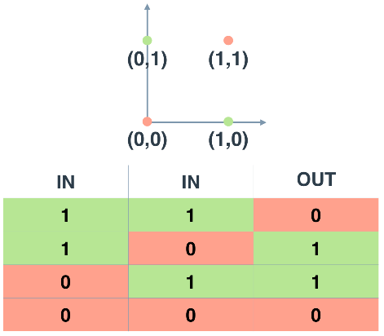

XOR Truth Table and Graph

An XOR perceptron is a logic gate that outputs 0 if the inputs are the same and 1 if the inputs are different. Unlike previous perceptrons, this graph isn't linearly separable. To handle more complex problems like this, we can chain perceptrons together.

Let's build a neural network from the AND, NOT, and OR perceptrons to create XOR logic. Let's first go over what a neural network looks like.

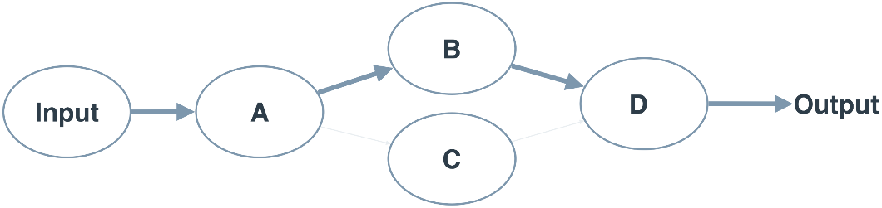

The above neural network contains 4 perceptrons, A, B, C, and D. The input to the neural network is from the first node. The output comes out of the last node. The weights are based on the line thickness between the perceptrons. Any link between perceptrons with a low weight, like A to C, you can ignore. For perceptron C, you can ignore all input to and from it. For simplicity we wont be showing bias, but it's still in the neural network.

## Quiz

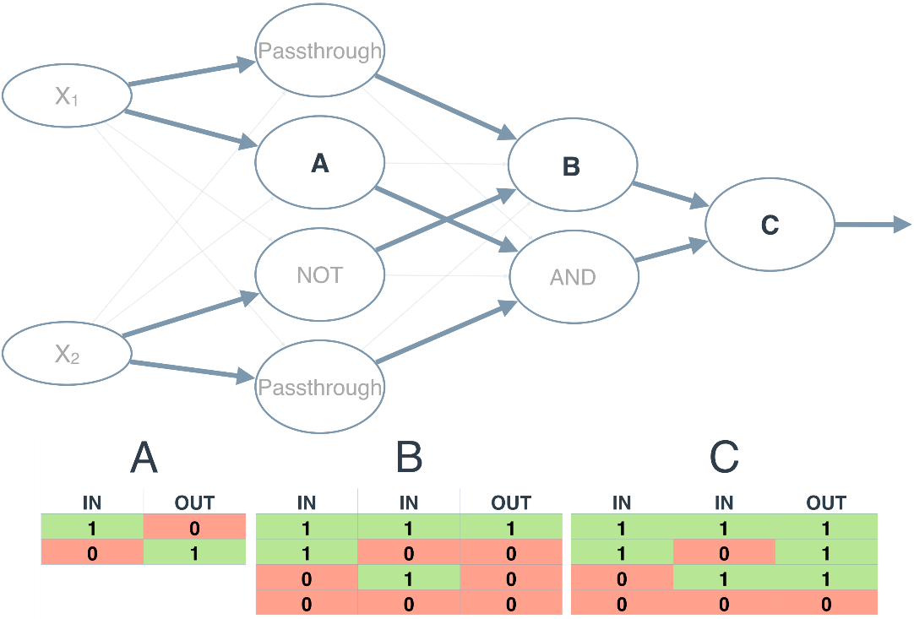

The neural network above calculates XOR. Each perceptron is a logic operation of OR, AND, Passthrough, or NOT. The **[Passthrough](https://en.wikipedia.org/wiki/Passthrough" \t "_blank)** operation just passes it's input to the output. However, the perceptrons A , B, and C don't indicate their operation. In the following quiz, set the correct operations for the three perceptrons to calculate XOR.

Note: Any line with a low weight can be ignored.

### **QUIZ QUESTION**

Set the operations for the perceptrons in the XOR neural network?

NOT

AND

OR

You've seen that a perceptron can solve linearly separable problems. Solving more complex problems, you use more perceptrons. You saw this by calculating AND, OR, NOT, and XOR operations using perceptrons. These operations can be used to create any computer program. With enough data and time, a neural network can solve any problem that a computer can calculate. However, you don't build a Twitter using a neural network. A neural network is like any tool, you have to know when to use it.

The power of a neural network isn't building it by hand, like we were doing. It's the ability to learn from examples. In the next few sections, you'll learn how a neural networks sets it's own weights and biases.

# The simplest neural network

So far you've been working with perceptrons where the output is always one or zero. The input to the output unit is passed through an activation function, *f*(*h*), in this case, the step function.



The step activation function.

Here, *h* is the input to the output unit,

*h*=∑​*i*​​*w*​*i*​​*x*​*i*​​+*b*.

You can see an example below, with the output of the perceptron labeled *a*.

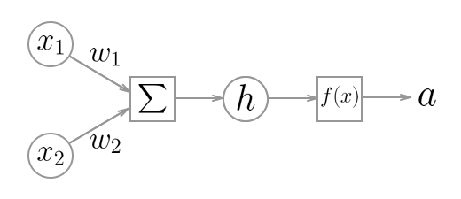

Diagram of a simple neural network. Circles are units, boxes are operations.

The cool part about this architecture, and what makes neural networks possible, is that the activation function, *f*(*h*) can be any function.

For example, if you let *f*(*h*)=*h* the output will be the same as the input. Now the output of the network is

*a*=∑​*i*​​*w*​*i*​​*x*​*i*​​+*b*.

This equation should be familiar to you, it's the same as the linear regression model!

Other activation functions you'll see are the logistic (often called the sigmoid), tanh, and softmax functions. We'll mostly be using the sigmoid function for the rest of this lesson:

sigmoid(*x*)=1/(1+*e*​−*x*​​)

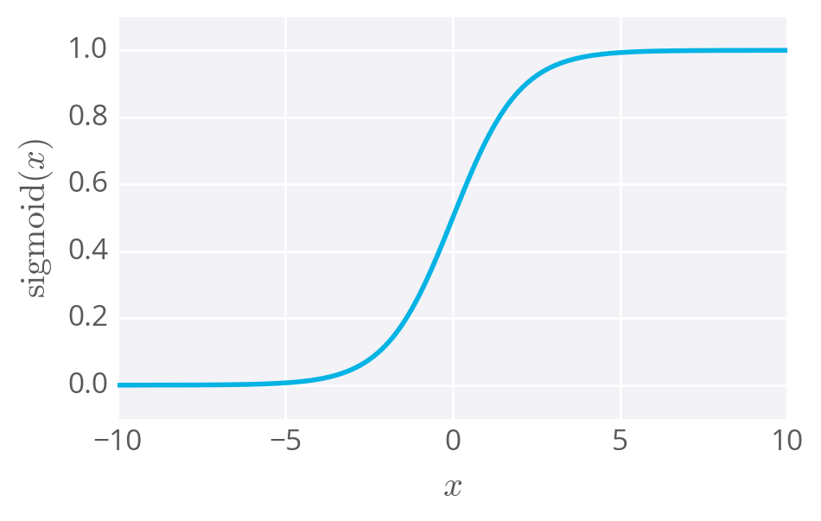

The sigmoid function

The sigmoid function is bounded between 0 and 1, and as an output can be interpreted as a probability for success. It turns out, again, using a sigmoid as the activation function results in the same formulation as logistic regression.

This is where it stops being a perceptron and begins being called a neural network. In the case of simple networks like this, neural networks don't offer any advantage over general linear models such as logistic regression. But, as you saw with the XOR perceptron, stacking units will let you model linearly inseparable data, impossible to do with regression models.

Once you start using activation functions that are continuous and differentiable, it's possible to train the network using gradient descent, which you'll learn about next.

## Simple network exercise

Below, you'll use Numpy to calculate the output of a simple network with two input nodes and one output node with a sigmoid activation function. Thing's you'll need to do:

* Implement the sigmoid function.
* Calculate the output of the network.

As a reminder, the sigmoid function is

sigmoid(*x*)=1/(1+*e*​−*x*​​)

For the exponential, you can use Numpy's exponential function, np.exp.

And the output of the network is

*a*=*f*(*h*)=sigmoid(∑​*i*​​*w*​*i*​​*x*​*i*​​+*b*)

For the weights sum, you can do a simple element-wise multiplication and sum, or Numpy's [**dot product function**](https://docs.scipy.org/doc/numpy/reference/generated/numpy.dot.html).

# Learning weights

You've seen how you can use perceptrons for AND and XOR operations, but there we set the weights by hand. What if you want to perform an operation, such as predicting college admission, but don't know the correct weights? You'll need to learn the weights from example data, then use those weights to make the predictions.

To figure out how we're going to find these weights, start by thinking about the goal. We want the network to make predictions as close as possible to the real values. To measure this, we need a metric of how wrong the predictions are, the **error**. A common metric is the sum of the squared errors (SSE):

*E*=​2​​1​​∑​*μ*​​∑​*j*​​[*y*​*j*​*μ*​​−​*y*​^​​​*j*​*μ*​​]​2​​

where ​*y*​^​​ is the prediction and *y* is the true value, and you take the sum over all output units *j* and another sum over all data points *μ*. The SSE is a good choice for a few reasons. The square ensures the error is always positive and larger errors are penalized more than smaller errors. Also, it makes the math nice, always a plus.

Remember that the output of a neural network, the prediction, depends on the weights

​*y*​^​​​*j*​*μ*​​=*f*(∑​*i*​​*w*​*ij*​​*x*​*i*​*μ*​​)

and accordingly the error depends on the weights

*E*=​2​​1​​∑​*μ*​​∑​*j*​​[*y*​*j*​*μ*​​−*f*(∑​*i*​​*w*​*ij*​​*x*​*i*​*μ*​​)]​2​​

We want the network's prediction error to be as small as possible and the weights are the knobs we can use to make that happen. Our goal is to find weights *w*​*ij*​​ that minimize the squared error *E*. To do this with a neural network, typically you'd use **gradient descent**.

## Enter Gradient Descent

As Luis said, with gradient descent, we take multiple small steps towards our goal. In this case, we want to change the weights in steps that reduce the error. Continuing the analogy, the error is our mountain and we want to get to the bottom. Since the fastest way down a mountain is in the steepest direction, the steps taken should be in the direction that minimizes the error the most. We can find this direction by calculating the gradient of the squared error.

Gradient is another term for rate of change or slope. If you need to brush up on this concept, check out Khan Academy's [**great lectures**](https://www.khanacademy.org/math/multivariable-calculus/multivariable-derivatives/gradient-and-directional-derivatives/v/gradient) on the topic.

To calculate a rate of change, we turn to calculus, specifically derivatives. A derivative of a function *f*(*x*) gives you another function *f*​′​​(*x*) that returns the slope of *f*(*x*) at point *x*. For example, consider *f*(*x*)=*x*​2​​. The derivative of *x*​2​​ is *f*​′​​(*x*)=2*x*. So, at *x*=2, the slope is *f*​′​​(2)=4. Plotting this out, it looks like:

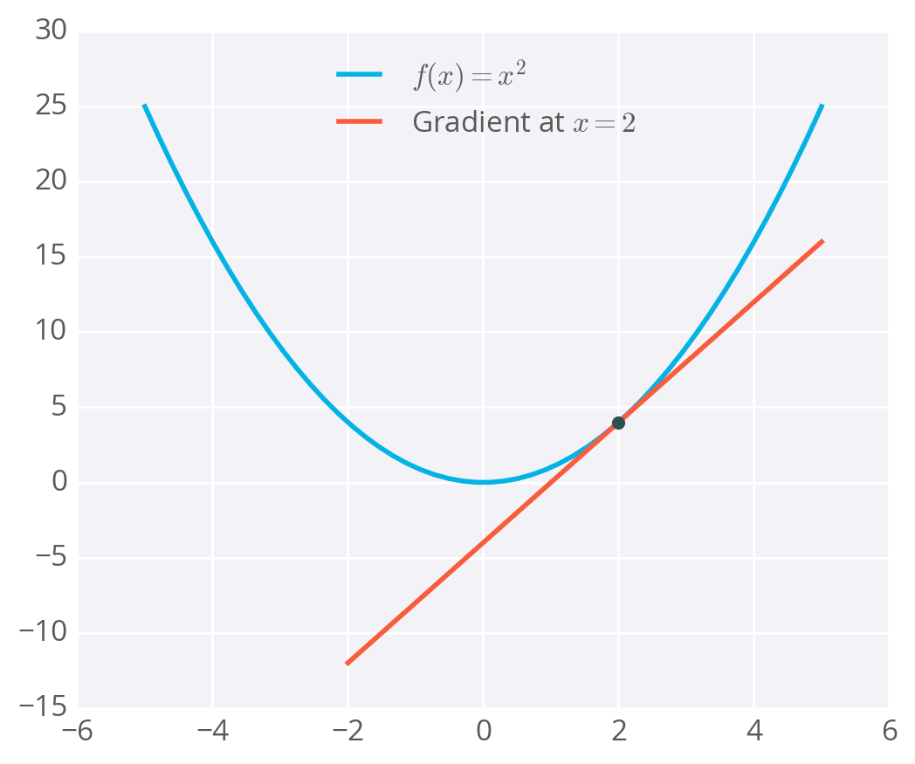

Example of a gradient

The gradient is just a derivative generalized to functions with more than one variable. We can use calculus to find the gradient at any point in our error function, which depends on the input weights.

### Math time

Our goal here is to calculate the gradient of the error which means we need the partial derivatives of the error with respect to each of the weights. To keep things simple, I'm only going to consider one update step from one data point. From before, the error is:

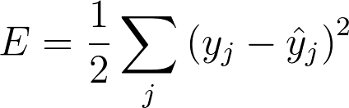

and the prediction ​*y*​^​​​*j*​​ is

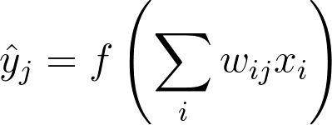

We want to update our weights by an amount Δ*w*​*ij*​​ proportional to the gradient of the error, but in the opposite direction (hence the negative sign below). This gives us the following equation for Δ*w*​*ij*​​:

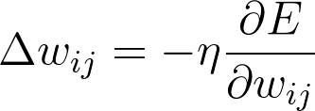

Here, *η* is the learning rate which allows us to scale the step size in the gradient descent updates.

Let's now understand what ​∂*w*​*ij*​​​​∂*E*​​ will be. We're going to be using the chain rule here so be sure to brush up on it [**here**](https://www.khanacademy.org/math/ap-calculus-ab/product-quotient-chain-rules-ab/chain-rule-ab/v/chain-rule-introduction).

Remember, *E*=​2​​1​​∑​*j*​​[(*y*​*j*​​−​*y*​*j*​​​^​​)​2​​].

Using the chain rule,

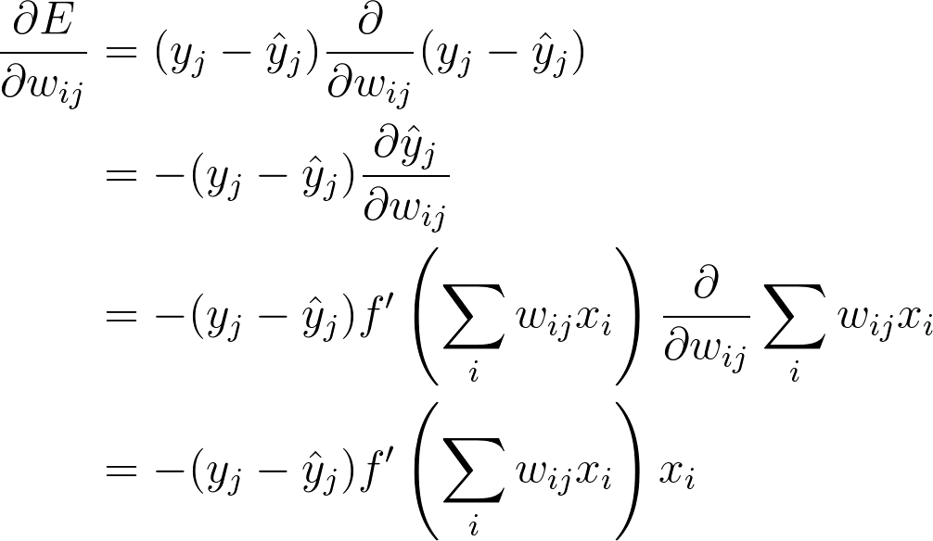

And finally, putting everything together,

https://d17h27t6h515a5.cloudfront.net/topher/2017/January/588ac7c8_grad-weight-step/grad-weight-step.png

where *h*​*j*​​ is the input to the output unit *j*

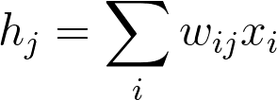

Let's go over the intuition for this result. (*y*​*j*​​−​*y*​^​​​*j*​​) is the prediction error. The larger this error is, the larger the step should be. When the error is small, our steps can be smaller since the weights are near the minimum. Similarly, there's the input term, *x*​*i*​​. Since larger inputs drive more error, we scale the weight proportional to this term.

The next part is the gradient, *f*​′​​(*h*​*j*​​). This is proportional to the effect unit *j* has on the output. Remember that the gradient is a rate of change. If the gradient is small, then a change in the unit input *h*​*j*​​ will have a small effect on the error. And conversely, if the gradient is large, a change in the unit input will have a large effect. This term produces larger gradient descent steps for units that have larger gradients and therefore effect the change in error more.

If we define the errors, *δ*​*j*​​, as

https://d17h27t6h515a5.cloudfront.net/topher/2017/January/588ac949_delta/delta.png

then we can write the gradient descent step as

https://d17h27t6h515a5.cloudfront.net/topher/2017/January/588ac981_weight-step-delta/weight-step-delta.png

This notation will come in handy later when we're dealing with backpropagation.

Note: You might be wondering how bias terms work with this. For most of this lesson, the bias term will be implicit in derivations and code examples. It's really easy to deal with biases though, you use the normal weight results, but set *x*​*i*​​=1. So, Δ*b*​*j*​​=*ηδ*​*j*​​.

Below I've plotted an example of the error of a neural network with two inputs, and accordingly, two weights. You can read this like a topographical map where points on a contour line have the same error and darker contour lines correspond to larger errors.

At each step, you calculate the error and the gradient, then use those to determine how much to change each weight. Repeating this process will eventually find weights that are close to the minimum of the error function, the block dot in the middle.

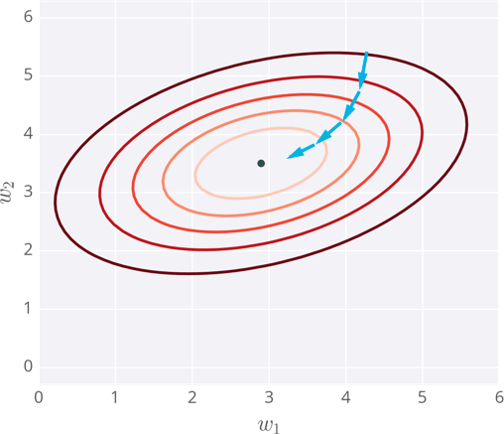

Gradient descent steps to the lowest error

# Caveats

Since the weights will just go where ever the gradient takes them, they can end up where the error is low, but not the lowest. These spots are called local minima. If the weights are initialized with the wrong values, gradient descent could lead the weights into a local minimum, illustrated below.

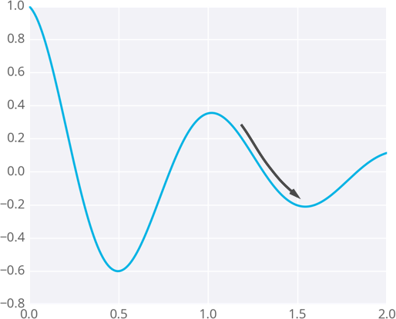

Gradient descent leading into a local minimum

There are methods to avoid this, such as using [**momentum**](http://sebastianruder.com/optimizing-gradient-descent/index.html#momentum).

## Gradient descent exercise

Below, you'll calculate one gradient descent step for the weights of a simple network with two inputs and one output unit. Your goal here is to calculate the correct weight step using gradient descent.

Remember that the weight step is the learning rate times the error times the input values:

Δ*w*​*ij*​​=*ηδ*​*j*​​*x*​*i*​​.

You'll need to calculate the error gradient, *δ*​*j*​​=(*y*−​*y*​^​​)*f*​′​​(*h*), which consists of the output error (the target *y*minus the output ​*y*​^​​) and the gradient of the activation function. A nice thing about using the sigmoid function for the activations is that it's derivative can be written in terms of the sigmoid function itself:

*f*​′​​(*h*)=*f*(*h*)(1−*f*(*h*)).

You calculate *f*(*h*) to get the output, it's the activation of the output unit. So you can just use that for the derivative in the error.

import numpy as np

def sigmoid(x):

"""

Calculate sigmoid

"""

return 1/(1+np.exp(-x))

learnrate = 0.5

x = np.array([1, 2])

y = np.array(0.5)

# Initial weights

w = np.array([0.5, -0.5])

# Calculate one gradient descent step for each weight

# TODO: Calculate output of neural network

nn\_output = None

# TODO: Calculate error of neural network

error = None

# TODO: Calculate change in weights

del\_w = None

print('Neural Network output:')

print(nn\_output)

print('Amount of Error:')

print(error)

print('Change in Weights:')

print(del\_w)

# Implementing gradient descent

Okay, now we know how to update our weights

Δ*w*​*ij*​​=*ηδ*​*j*​​*x*​*i*​​,

how do we translate this into code?

As an example, I'm going to have you use gradient descent to train a network on graduate school admissions data (found at [**http://www.ats.ucla.edu/stat/data/binary.csv**](http://www.ats.ucla.edu/stat/data/binary.csv). This dataset has three input features: GRE score, GPA, and the rank of the undergraduate school (numbered 1 through 4). Institutions with rank 1 have the highest prestige, those with rank 4 have the lowest.

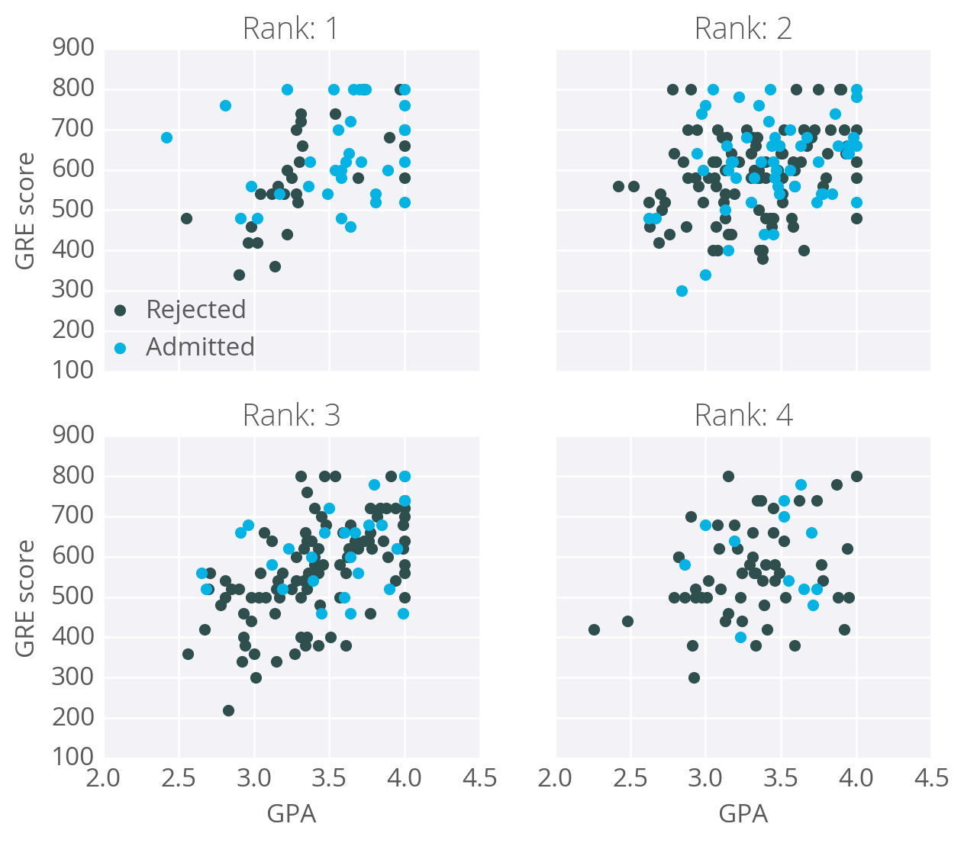

The goal here is to predict if a student will be admitted to a graduate program based on these features. For this, we'll use a network with one output layer with one unit. We'll use a sigmoid function for the output unit activation.

## Data cleanup

You might think there will be three input units, but we actually need to transform the data first. The rankfeature is categorical, the numbers don't encode any sort of relative values. Rank 2 is not twice as much as rank 1, rank 3 is not 1.5 more than rank 2. Instead, we need to use [**dummy variables**](https://en.wikipedia.org/wiki/Dummy_variable_(statistics)) to encode rank, splitting the data into four new columns encoded with ones or zeros. Rows with rank 1 have one in the rank 1 dummy column, and zeros in all other columns. Rows with rank 2 have one in the rank 2 dummy column, and zeros in all other columns. And so on.

We'll also need to standardize the GRE and GPA data, which means to scale the values such they have zero mean and a standard deviation of 1. This is necessary because the sigmoid function squashes really small and really large inputs. The gradient of really small and large inputs is zero, which means that the gradient descent step will go to zero too. Since the GRE and GPA values are fairly large, we have to be really careful about how we initialize the weights or the gradient descent steps will die off and the network won't train. Instead, if we standardize the data, we can initialize the weights easily and everyone is happy.

This is just a brief run-through, you'll learn more about preparing data later. If you're interested in how I did this, check out the data\_prep.py file in the programming exercise below.

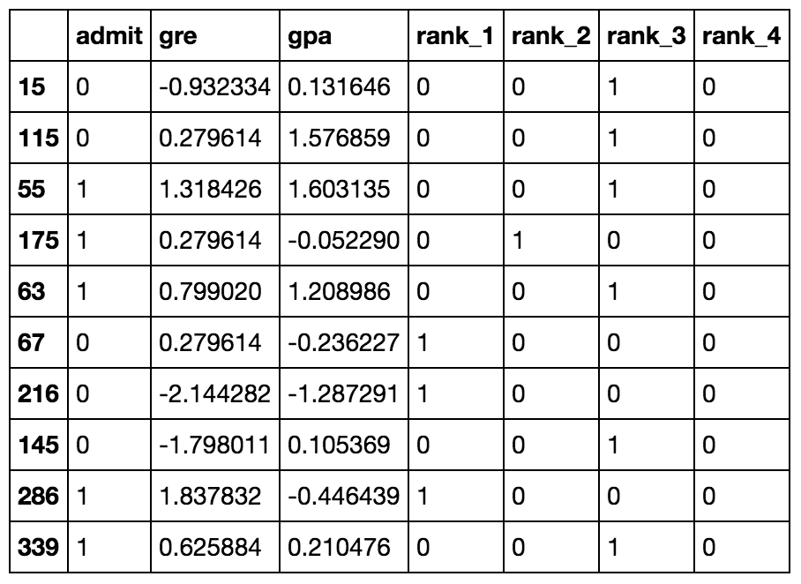

Ten rows of the data after transformations.

Now that the data is ready, we see that there are six input features: gre, gpa, and the four rank dummy variables.

Here's the general algorithm for updating the weights with gradient descent:

* Set the weight step to zero: Δ*w*​*i*​​=0
* For each record in the training data:
  + Make a forward pass through the network, calculating the output ​*y*​^​​=*f*(∑​*i*​​*w*​*i*​​*x*​*i*​​)
  + Calculate the error gradient in the output unit, *δ*=(*y*−​*y*​^​​)∗*f*​′​​(∑​*i*​​*w*​*i*​​*x*​*i*​​)
  + Update the weight step Δ*w*​*i*​​=Δ*w*​*i*​​+*δx*​*i*​​
* Update the weights *w*​*i*​​=*w*​*i*​​+*η*Δ*w*​*i*​​/*m* where *η* is the learning rate and *m* is the number of records. Here we're averaging the weight steps to help reduce any large variations in the training data.
* Repeat for *e* epochs.

You can also update the weights on each record instead of averaging the weight steps after going through all the records.

Remember that we're using the sigmoid for the activation function, *f*(*h*)=1/(1+*e*​−*x*​​)

And the gradient of the sigmoid is *f*​′​​(*h*)=*f*(*h*)(1−*f*(*h*))

where *h* is the input to the output unit,

*h*=∑​*i*​​*w*​*i*​​*x*​*i*​​

## Implementing with Numpy

For the most part, this is pretty straightforward with Numpy.

First, you'll need to initialize the weights. We want these to be small such that the input to the sigmoid is in the linear region near 0 and not squashed at the high and low ends. It's also important to initialize them randomly so that they all have different starting values and diverge, breaking symmetry. So, we'll initialize the weights from a normal distribution centered at 0. A good value for the scale is 1/√​*n*​​​ where *n* is the number of input units. This keeps the input to the sigmoid low for increasing numbers of input units.

weights = np.random.normal(scale=1/n\_features\*\*-.5, size=n\_features)

Numpy provides a function that calculates the dot product of two arrays, which conveniently calculates *h* for us. The dot product multiplies two arrays element-wise, the first element in array 1 is multiplied by the first element in array 2, and so on. Then, each product is summed.

*# input to the output layer*

output\_in = np.dot(weights, inputs)

And finally, we can update Δ*w*​*i*​​ and *w*​*i*​​ by incrementing them with weights += ... which is shorthand for weights = weights + ....

### Efficiency tip!

You can save some calculations since we're using a sigmoid here. For the sigmoid function, *f*​′​​(*h*)=*f*(*h*)(1−*f*(*h*)). That means that once you calculate *f*(*h*), the activation of the output unit, you can use it to calculate the gradient for the error gradient.

## Programming exercise

Below, you'll implement gradient descent and train the network on the admissions data. Your goal here is to train the network until you reach a minimum in the mean square error (MSE) on the training set. You need to implement:

* The network output: output.
* The error gradient: error.
* Update the weight step: del\_w +=.
* Update the weights: weights +=.

After you've written these parts, run the training by pressing "Test Run". The MSE will print out, as well as the accuracy on a test set, the fraction of correctly predicted admissions.

Feel free to play with the hyperparameters and see how it changes the MSE.

# Multilayer perceptron: Implementing the hidden layer

##### Prerequisites

Below, we are going to walk through the math of neural networks in a multilayer perceptron. With multiple perceptrons, we are going to move to using vectors and matrices. To brush up, be sure to view the following:

1. Khan Academy's [**introduction to vectors**](https://www.khanacademy.org/math/linear-algebra/vectors-and-spaces/vectors/v/vector-introduction-linear-algebra).
2. Khan Academy's [**introduction to matrices**](https://www.khanacademy.org/math/precalculus/precalc-matrices).

##### Derivation

Before, we were dealing with only one output node which made the code straightforward. However now we have multiple input units and multiple hidden units, the weights between them now require two indices: *w*​*ij*​​where *i* denotes input units and *j* are the hidden units. Before, we were able to write *w*​*i*​​ as an array.

But now, *w*​*ij*​​ is a matrix. If we have three input units and two hidden units, the weights matrix looks like this:

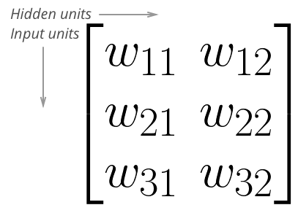

Weights matrix for 3 input units and 2 hidden units

To initialize these weights in Numpy, we have to provide the shape of the matrix. If features is a 2D array containing the input data:

*# Number of records and input units*

n\_records, n\_inputs = features.shape

*# Number of hidden units*

n\_hidden = 2

weights = np.random.normal(0, n\_inputs\*\*-0.5, shape=(n\_inputs, n\_hidden))

This creates a 2D array weights with dimensions n\_inputs by n\_hidden. Now, if we want to calculate the inputs to the hidden layer *h*​*j*​​:

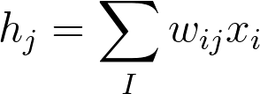

we need to use [**matrix multiplication**](https://en.wikipedia.org/wiki/Matrix_multiplication). If your linear algebra is rusty, I suggest taking a look at the suggested resources in the prerequisites section. For this part though, you'll only need to know how to multiply a matrix with a vector.

In this case, we're multiplying the inputs (a row vector here) by the weights. To do this, you take the dot (inner) product of the inputs with each column in the weights matrix. For example, to calculate the input to the first hidden unit, *j*=1, you'd take the dot product of the inputs with the first column of the weights matrix, like so:

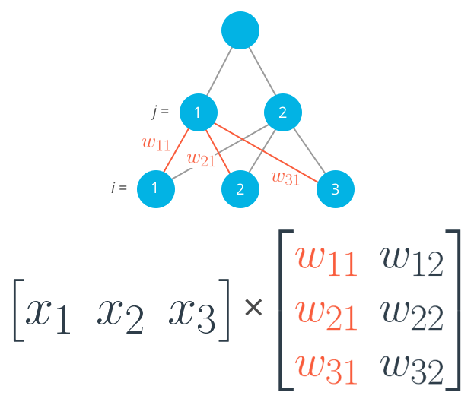

Calculating the input to the first hidden unit with the first column of the weights matrix.

https://d17h27t6h515a5.cloudfront.net/topher/2017/January/588ae392_codecogseqn-2/codecogseqn-2.png

And for the second hidden layer input, you calculate the dot product of the inputs with the second column. And so on and so forth.

In Numpy, again, you do this with np.dot

hidden\_inputs = np.dot(inputs, weights\_input\_to\_hidden)

You could also define your weights matrix such that it has dimensions n\_hidden by n\_inputs then multiply like so where the inputs form a column vector:

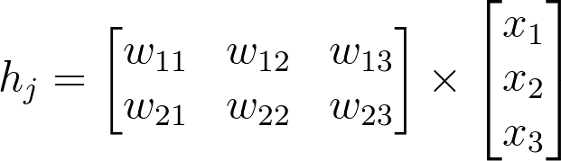

The important thing is that the dimensions match. For the matrix multiplication to work, there has to be the same number of elements in the dot products. In the first example, there are three columns in the input vector, and three rows in the weights matrix. In the second example, there are three columns in the weights matrix and three rows in the input vector. If the dimensions don't match, you'll get this:

# Same weights and features as above, but swapped the order

hidden\_inputs = np.dot(weights\_in\_hidden, features)

---------------------------------------------------------------------------

ValueError Traceback (most recent call last)

<ipython-input-11-1bfa0f615c45> in <module>()

----> 1 hidden\_in = np.dot(weights\_in\_hidden, X)

ValueError: shapes (3,2) and (3,) not aligned: 2 (dim 1) != 3 (dim 0)

The dot product can't be computed for a 3x2 matrix and 3-element array. That's because the 2 columns in the matrix don't match the number of elements in the array. Some of the dimensions that could work would be the following:

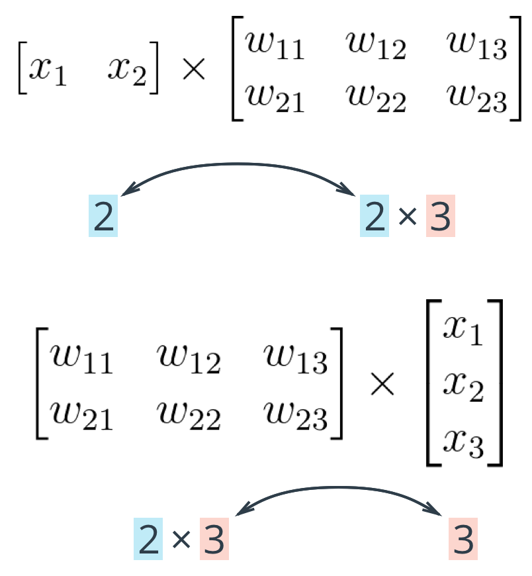

The rule is that if you're multiplying an array from the left, the array must have the same number of elements as there are rows in the matrix. And if you're multiplying the matrix from the left, the number of columns in the matrix must equal the number of elements in the array on the right.

### Making a column vector

You see above that sometimes you'll want a column vector, even though by default Numpy arrays work like row vectors. It's possible to get the transpose of an array like so arr.T, but for a 1D array, the transpose will return a row vector. Instead, use arr[:,None] to create a column vector:

print(features)

> array([ 0.49671415, -0.1382643 , 0.64768854])

print(features.T)

> array([ 0.49671415, -0.1382643 , 0.64768854])

print(features[:, **None**])

> array([[ 0.49671415],

[-0.1382643 ],

[ 0.64768854]])

Alternatively, you can create arrays with two dimensions. Then, you can use arr.T to get the column vector.

np.array(features, ndmin=2)

> array([[ 0.49671415, -0.1382643 , 0.64768854]])

np.array(features, ndmin=2).T

> array([[ 0.49671415],

[-0.1382643 ],

[ 0.64768854]])

I personally prefer keeping all vectors as 1D arrays, it just works better in my head.

## Programming quiz

Below, you'll implement a forward pass through a 4x3x2 network, with sigmoid activation functions for both layers.

Things to do:

* Calculate the input to the hidden layer.
* Calculate the hidden layer output.
* Calculate the input to the output layer.
* Calculate the output of the network.

# Backpropagation for multi layer perceptron’s

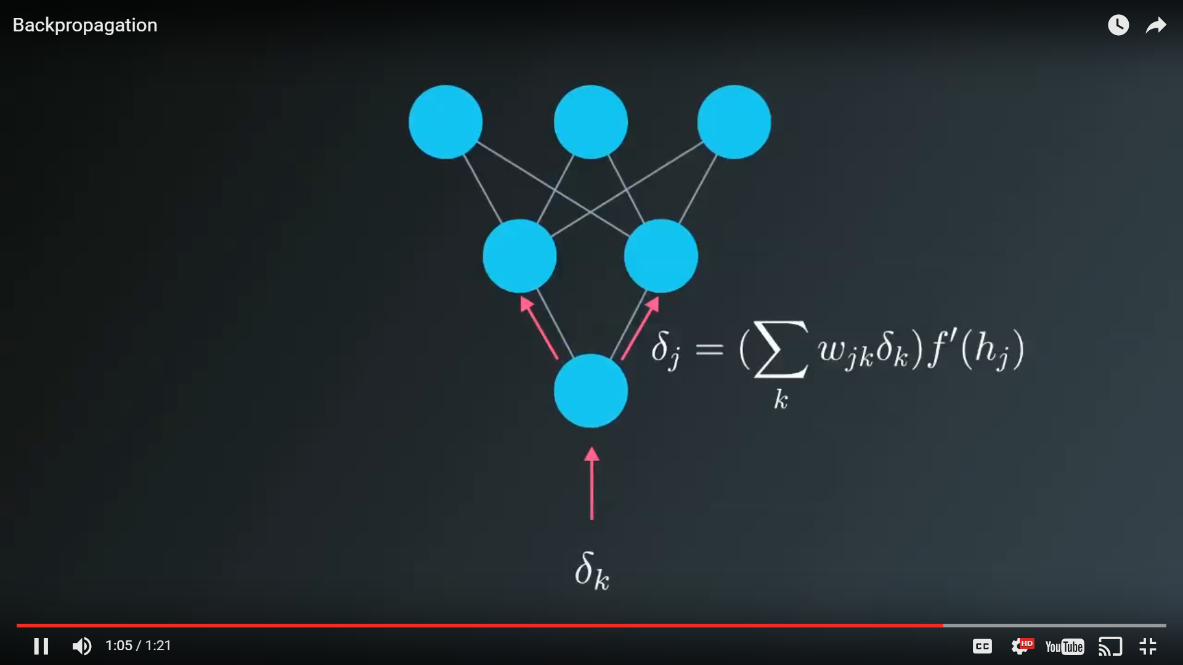

Think of backpropagation as flowing error forward in the inverted DNN.

Now we've come to the problem of how to make a multilayer neural network learn. Before, we saw how to update weights with gradient descent. The backpropagation algorithm is just an extension of that, using the chain rule to find the error with the respect to the weights connecting the input layer to the hidden layer (for a two layer network).

To update the weights to hidden layers using gradient descent, you need to know how much error each of the hidden units contributed to the final output. Since the output of a layer is determined by the weights between layers, the error resulting from units is scaled by the weights going forward through the network. Since we know the error at the output, we can use the weights to work backwards to hidden layers.

For example, in the output layer, you have errors *δ*​*k*​*o*​​ attributed to each output unit *k*. Then, the error attributed to hidden unit *j* is the output errors, scaled by the weights between the output and hidden layers (and the gradient):

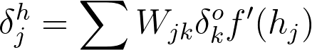

Then, the gradient descent step is the same as before, just with the new errors:

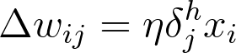

where *w*​*ij*​​ are the weights between the inputs and hidden layer and *x*​*i*​​ are input unit values. This form holds for however many layers there are. The weight steps are equal to the step size times the output error of the layer times the values of the inputs to that layer

https://d17h27t6h515a5.cloudfront.net/topher/2017/January/588bc2d4_backprop-general/backprop-general.gif

Here, you get the output error, *δ*​*output*​​, by propagating the errors backwards from higher layers. And the input values, *V*​*in*​​ are the inputs to the layer, the hidden layer activations to the output unit for example.

### Working through an example

Let's walk through the steps of calculating the weight updates for a simple two layer network. Suppose there are two input values, one hidden unit, and one output unit, with sigmoid activations on the hidden and output units. The following image depicts this network. (**Note:** the input values are shown as nodes at the bottom of the image, while the networks output value is shown as ​*y*​^​​ at the top. The inputs themselves do not count as a layer, which is why this is considered a two layer network.)

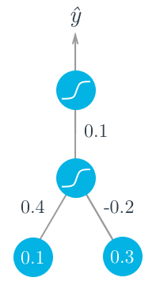

Assume we're trying to fit some binary data and the target is *y*=1. We'll start with the forward pass, first calculating the input to the hidden unit

*h*=∑​*i*​​*w*​*i*​​*x*​*i*​​=0.1×0.4−0.2×0.3=−0.02

and the output of the hidden unit

*a*=*f*(*h*)=sigmoid(−0.02)=0.495.

Using this as the input to the output unit, the output of the network is

​ *y*​^​​=*f*(*W*⋅*a*)=sigmoid(0.1×0.495)=0.512.

With the network output, we can start the backwards pass to calculate the weight updates for both layers. Using the fact that for the sigmoid function *f*​′​​(*W*⋅*a*)=*f*(*W*⋅*a*)(1−*f*(*W*⋅*a*)), the error for the output unit is

*δ*​*o*​​=(*y*−​*y*​^​​)*f*​′​​(*W*⋅*a*)=(1−0.512)×0.512×(1−0.512)=0.122.

Now we need to calculate the error for the hidden unit with backpropagation. Here we'll scale the error from the output unit by the weight *W* connecting it to the hidden unit. For the hidden unit error, *δ*​*j*​*h*​​=∑​*k*​​*W*​*jk*​​*δ*​*k*​*o*​​*f*​′​​(*h*​*j*​​), but since we have one hidden unit and one output unit, this is much simpler.

*δ*​*h*​​=*Wδ*​*o*​​*f*​′​​(*h*)=0.1×0.122×0.495×(1−0.495)=0.003

Now that we have the errors, we can calculate the gradient descent steps. The hidden to output weight step is the learning rate, times the output unit error, times the hidden unit activation value.

Δ*W*=*ηδ*​*o*​​*a*=0.5×0.122×0.495=0.0302

Then, for the input to hidden weights *w*​*i*​​, it's the learning rate times the hidden unit error, times the input values.

Δ*w*​*i*​​=*ηδ*​*h*​​*x*​*i*​​=(0.5×0.003×0.1,0.5×0.003×0.3)=(0.00015,0.00045)

From this example, you can see one of the effects of using the sigmoid function for the activations. The maximum derivative of the sigmoid function is 0.5, so the errors in the output layer get scaled by at least half, and errors in the hidden layer are scaled down by at least a quarter. You can see that if you have a lot of layers, using a sigmoid activation function will quickly reduce the weight steps to tiny values in layers near the input.

## Implementing in Numpy

For the most part you have everything you need to implement backpropagation with Numpy.

However, previously we were only dealing with error terms from one unit. Now, in the weight update, we have to consider the error for each unit in the hidden layer, *δ*​*i*​​:

Δ*w*​*ij*​​=*ηδ*​*i*​​*x*​*j*​​

Firstly, there will likely be a different number of input and hidden units, so trying to multiply the errors and the inputs as row vectors will throw an error

hidden\_error\*inputs

---------------------------------------------------------------------------

ValueError Traceback (most recent call last)

<ipython-input-22-3b59121cb809> in <module>()

----> 1 hidden\_error\*x

ValueError: operands could not be broadcast together with shapes (3,) (6,)

Also, *w*​*ij*​​ is a matrix now, so the right side of the assignment must have the same shape as the left side. Luckily, Numpy takes care of this for us. If you multiply a row vector array with a column vector array, it will multiply the first element in the column by each element in the row vector and set that as the first row in a new 2D array. This continues for each element in the column vector, so you get a 2D array that has shape (len(column\_vector), len(row\_vector)).

hidden\_error\*inputs[:,**None**]

array([[ -8.24195994e-04, -2.71771975e-04, 1.29713395e-03],

[ -2.87777394e-04, -9.48922722e-05, 4.52909055e-04],

[ 6.44605731e-04, 2.12553536e-04, -1.01449168e-03],

[ 0.00000000e+00, 0.00000000e+00, -0.00000000e+00],

[ 0.00000000e+00, 0.00000000e+00, -0.00000000e+00],

[ 0.00000000e+00, 0.00000000e+00, -0.00000000e+00]])

It turns out this is exactly how we want to calculate the weight update step. As before, if you have your inputs as a 2D array with one row, you can also do hidden\_error\*inputs.T, but that won't work if inputs is a 1D array.

## Backpropagation exercise

Below, you'll implement the code to calculate one backpropagation update step for two sets of weights. I wrote the forward pass, your goal is to code the backward pass.

Things to do

* Calculate the network error.
* Calculate the output layer error gradient.
* Use backpropagation to calculate the hidden layer error.
* Calculate the weight update steps.
* [**backprop.py**](https://classroom.udacity.com/nanodegrees/nd101/parts/2a9dba0b-28eb-4b0e-acfa-bdcf35680d90/modules/329a736b-1700-43d4-9bf0-753cc461bebc/lessons/dc37fa92-75fd-4d41-b23e-9659dde80866/concepts/87d85ff2-db15-438b-9be8-d097ea917f1e)
* [**solution.py**](https://classroom.udacity.com/nanodegrees/nd101/parts/2a9dba0b-28eb-4b0e-acfa-bdcf35680d90/modules/329a736b-1700-43d4-9bf0-753cc461bebc/lessons/dc37fa92-75fd-4d41-b23e-9659dde80866/concepts/87d85ff2-db15-438b-9be8-d097ea917f1e)

## Further reading

Backpropagation is fundamental to deep learning. TensorFlow and other libraries will perform the backprop for you, but you should really really understand the algorithm. We'll be going over backprop again, but here are some extra resources for you:

* From Andrej Karpathy: [**Yes, you should understand backprop**](https://medium.com/@karpathy/yes-you-should-understand-backprop-e2f06eab496b#.vt3ax2kg9)
* Also from Andrej Karpathy, [**a lecture from Stanford's CS231n course**](https://www.youtube.com/watch?v=59Hbtz7XgjM)